  - Cardinia Shire Council

Thriving Communities

Inclusion and Equity Strategy and Action Plan
2026–2030

DRAFT Easy Read version

What is in this document?
How to use this document — pages 3 & 4
Acknowledgement of Country – page 4
Message from our Mayor — page 5
Our strategy and why it matters — page 6
Different people, different needs — page 8
What people have told us — page 10
Our 5 areas of work — page 11
How we will check our work — page 18
Tell us what you think — page 19
What happens next? — page 20
Word list — page 21 & 22
Contact details — page 23

How to use this document
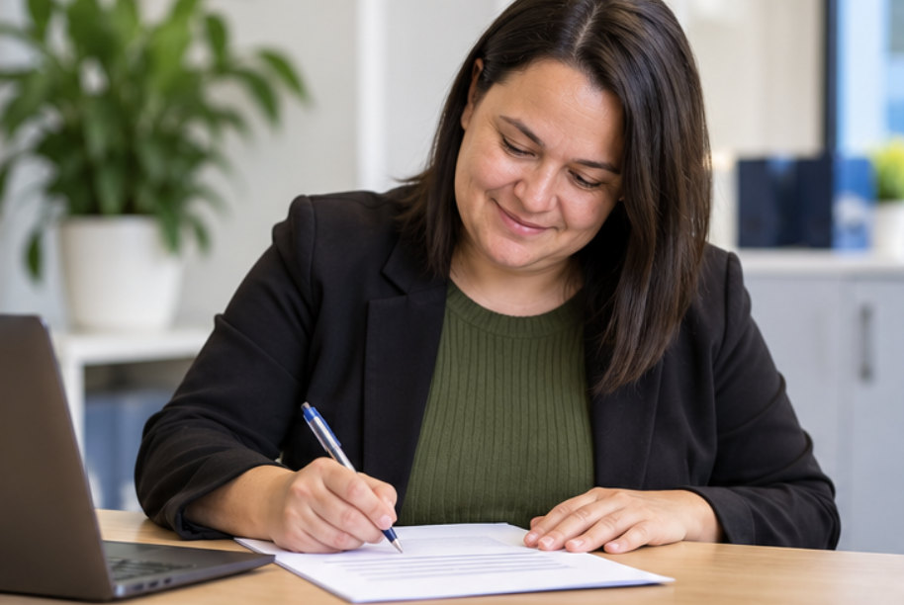 | Cardinia Shire Council wrote this document.  When we say “we”, we mean Council.

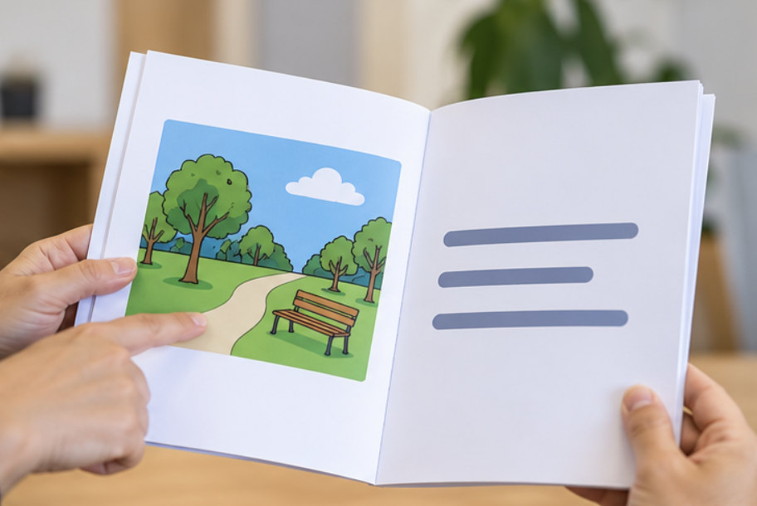 | We use pictures and short sentences to help explain our plan.

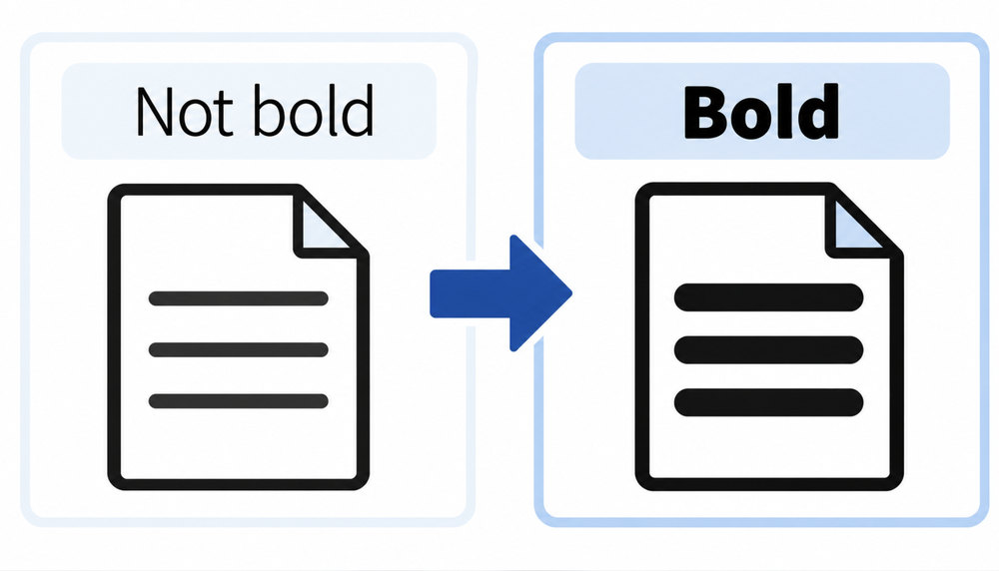 | We use bold words to show important ideas.  Bold letters are thicker and darker.
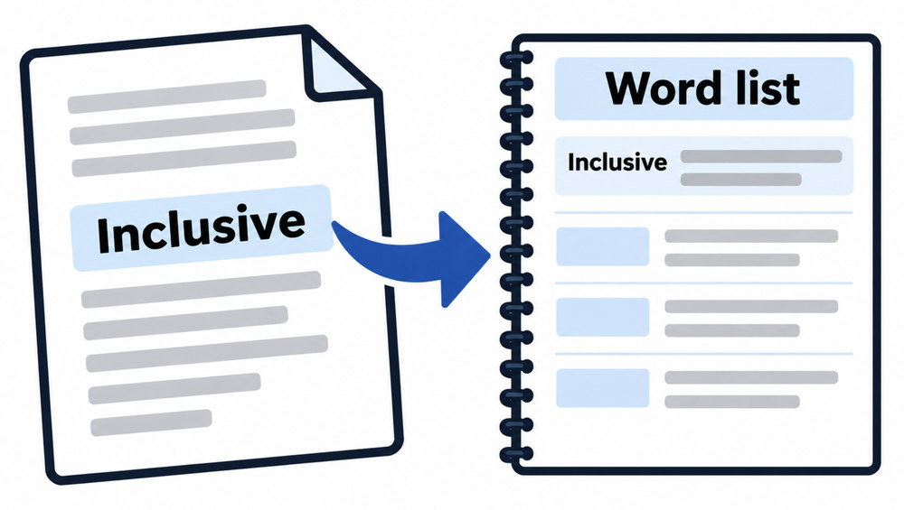 | You can find the bolded word meanings in the word list on page 20.
 | This is a summary of another strategy and action plan.  You can read the full strategy and action plan at our website: creating.cardinia.vic.gov.au

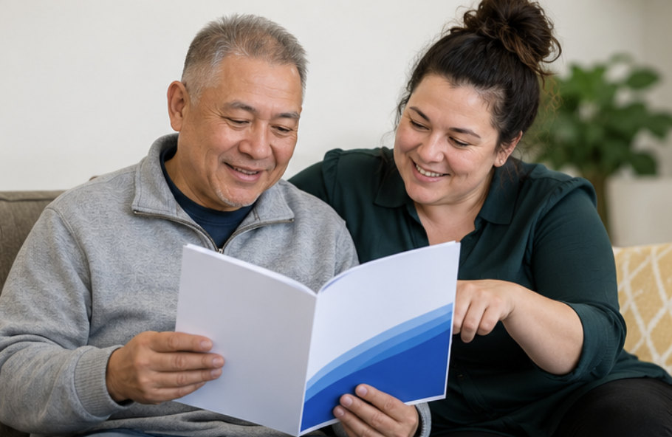 | You can ask a friend, family member or support person to help you read it.

Acknowledgement of Country
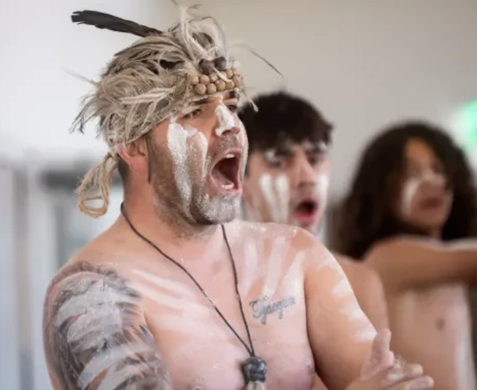 | We recognise that we live and work on the land  of the:  • Bunurong people  • Boonwurrung people  • Wurundjeri people.

Message from our Mayor
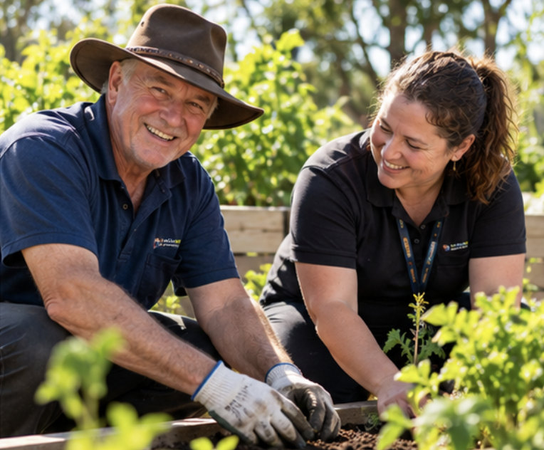 | We want Cardinia Shire to be a place where everyone feels valued and included
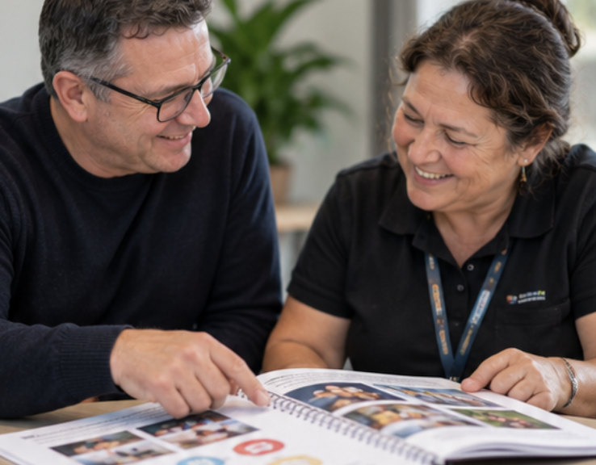 | Our Thriving Communities Strategy will help us ensure people can get access and take part in the community.
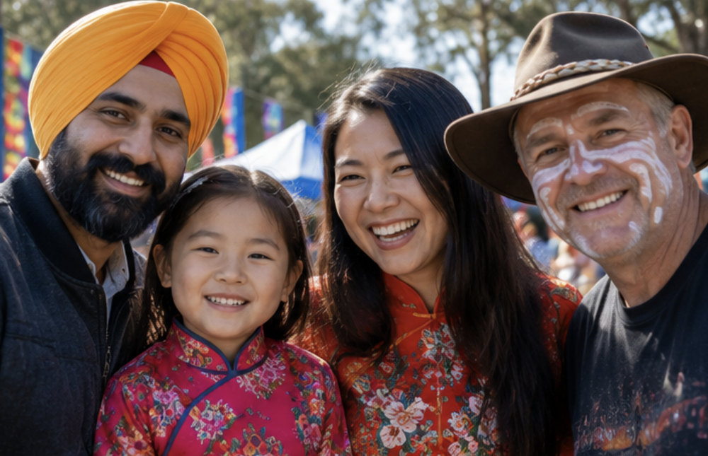 | We want to celebrate the different people and cultures in Cardinia Shire.
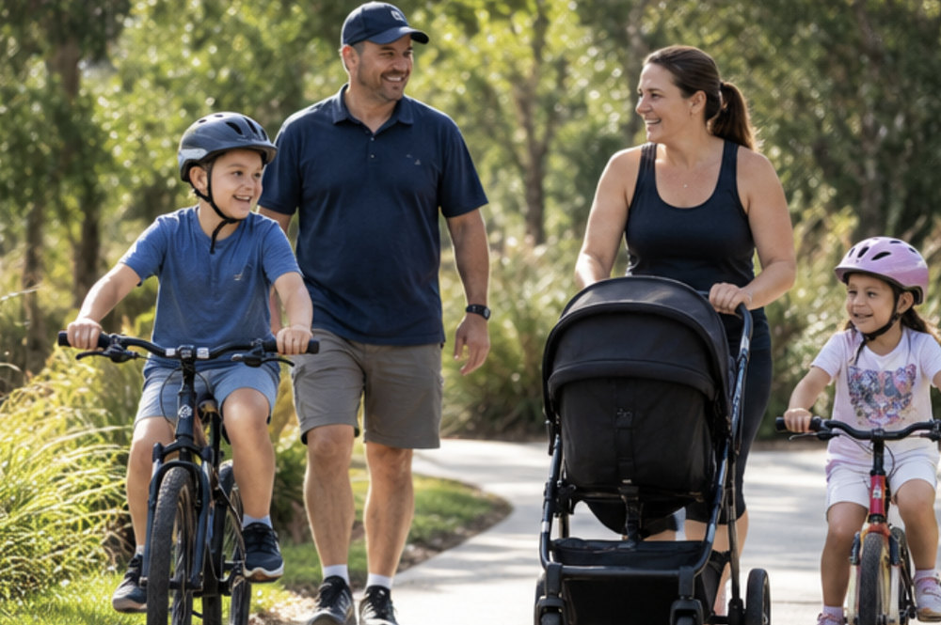 | We want everyone to have the chance to be healthy, connected and supported.
Cr Brett Owen, Mayor, Cardinia Shire Council

Our plan for Cardinia

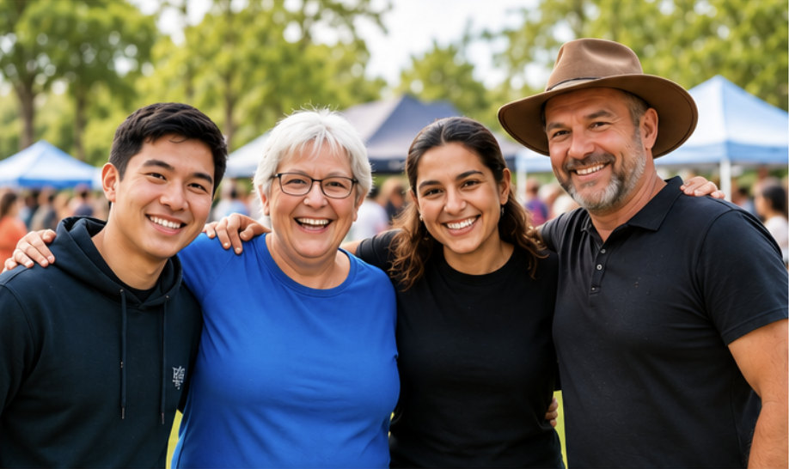 | We want Cardinia Shire to be a place where everyone feels welcome and can do well in life.

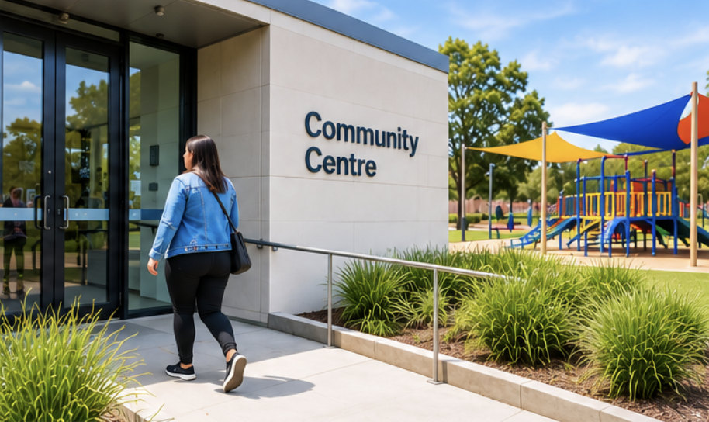 | People should be able to use Council services, visit public places and join community activities.

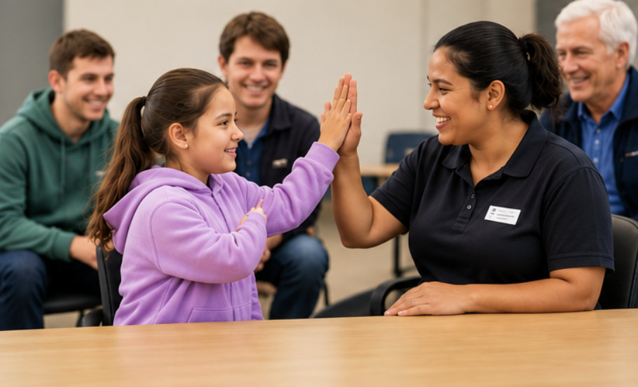 | We want everyone to be able to take part.  This is called inclusion.
 | Some people need different kinds of support to be able to join in.  This is called equity.

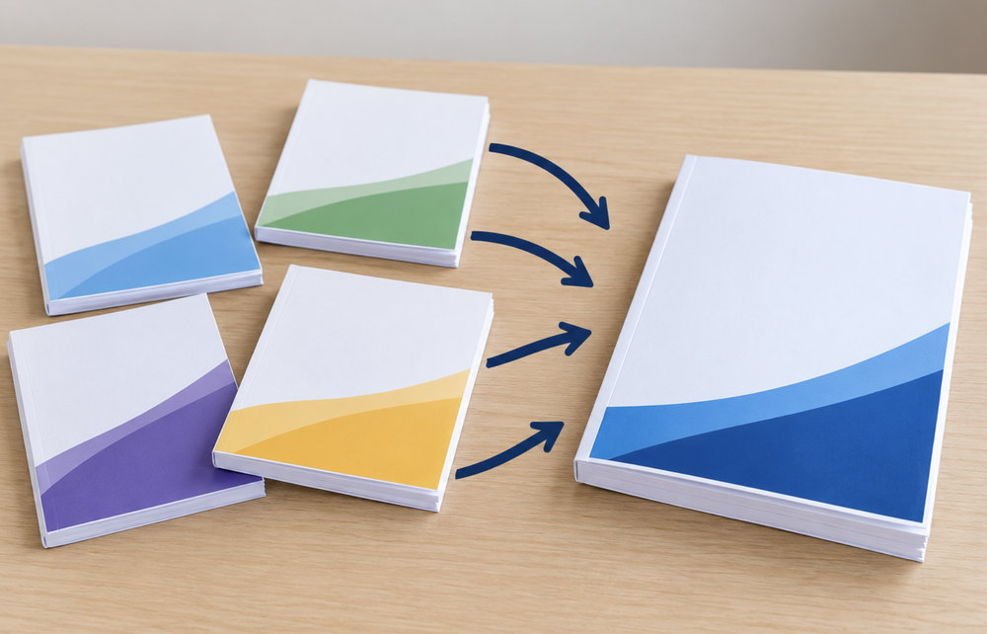 | Our strategy brings together our previous plans about disability, older people, children, families and cultural diversity.

Why this plan matters
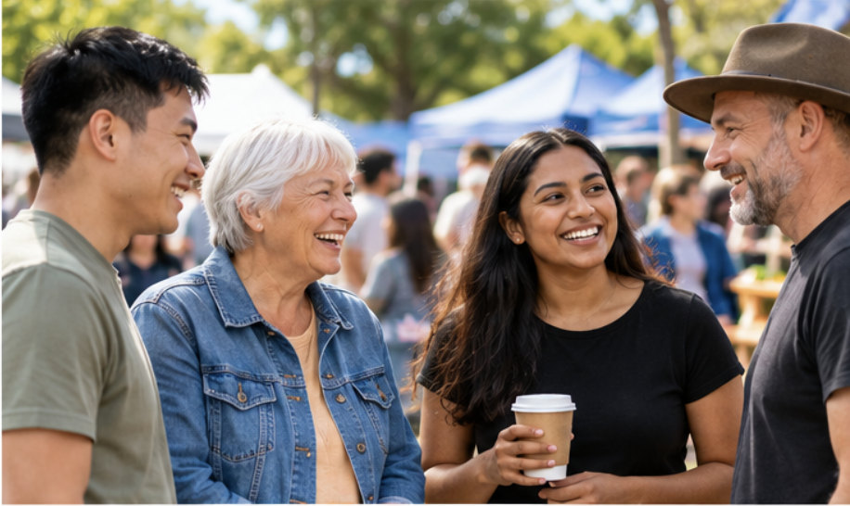 | Our community has many different people.  People bring different skills, experiences and ideas.

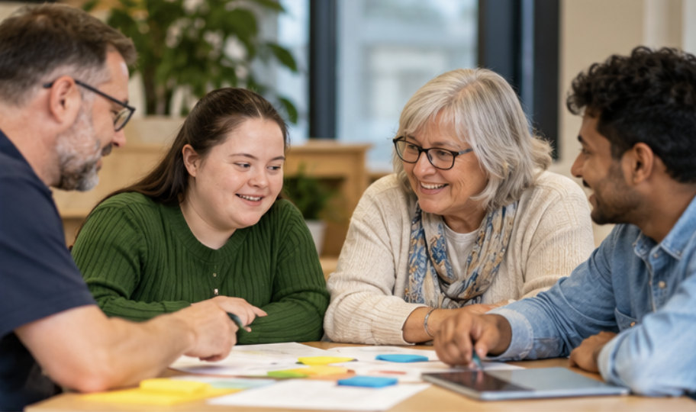 | People also have different needs.  Council services and places should work well for more people.

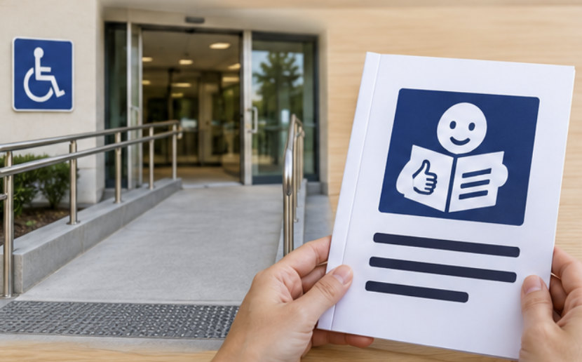 | For example, some people need step-free access to a building.  Some people need information in Easy Read.

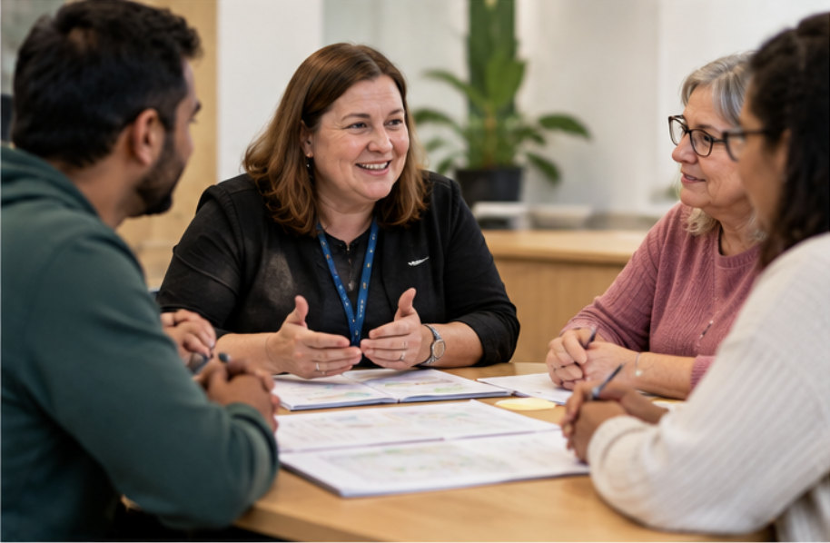 | We will listen to people and plan services with their needs in mind.

Different people, different needs
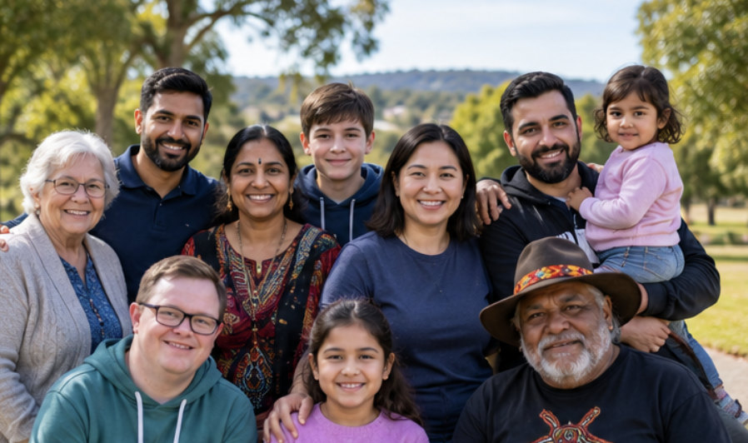 | Our age, disability, culture, family, gender and where we live can all shape our lives.

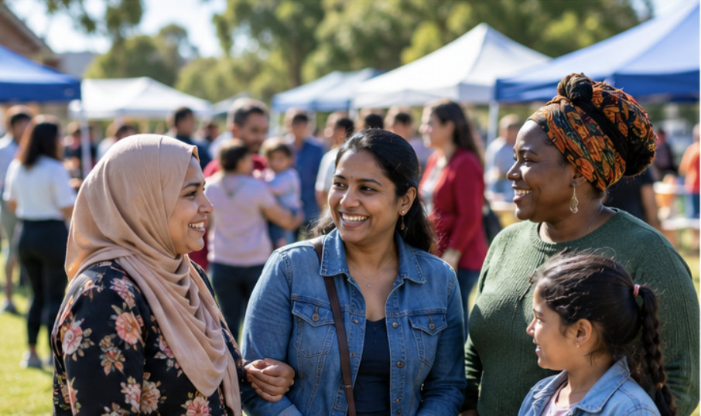 | A person may belong to more than one community.  All parts of their life can matter when they use a service.

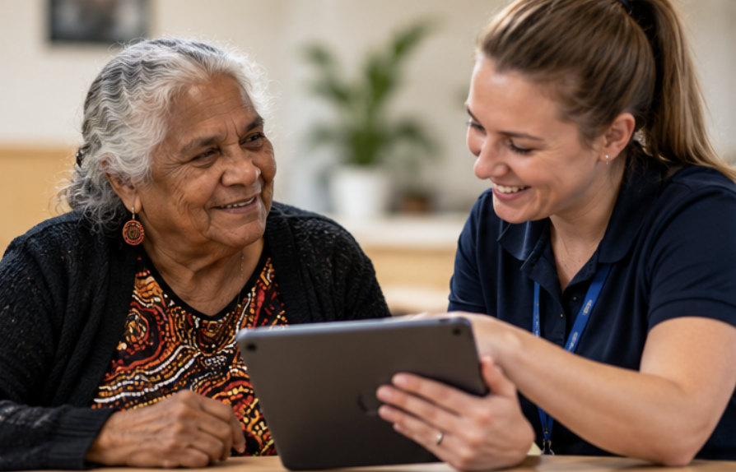 | For example, an older First Nations woman with disability may want support that respects her culture and is easy to use.

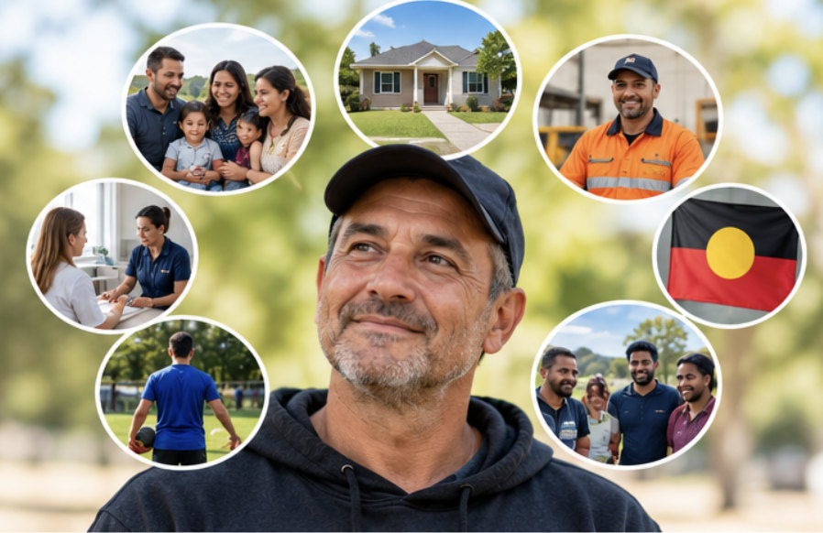 | We want to understand the whole person, not just one part of who they are.

Who is this plan for?
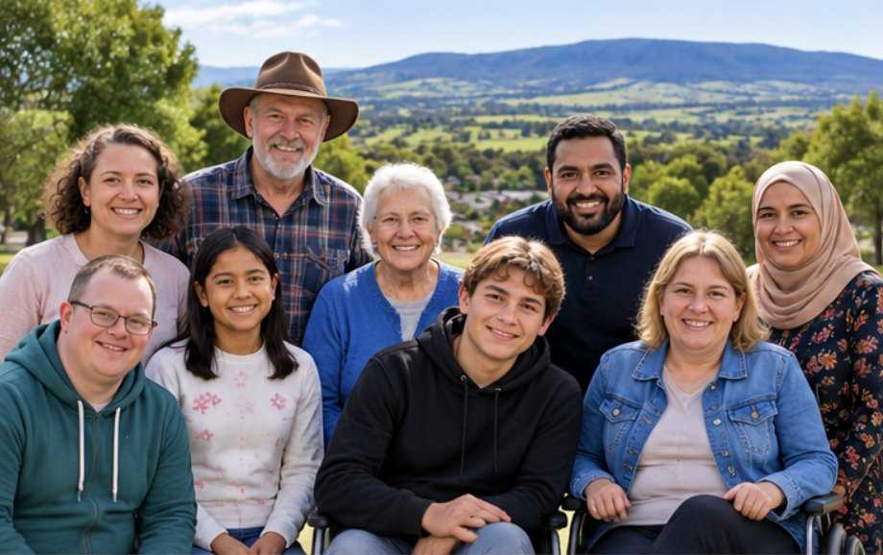 | The plan is for everyone in Cardinia Shire with a focus on some people.

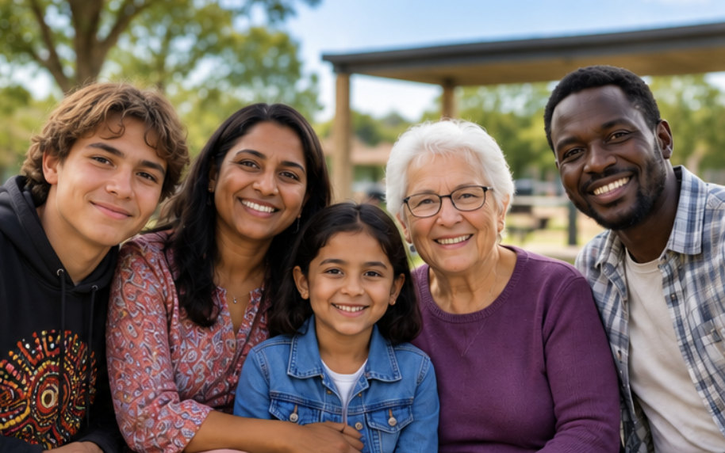 | It gives special attention to:  - people with disability  - First Nations peoples  - older people

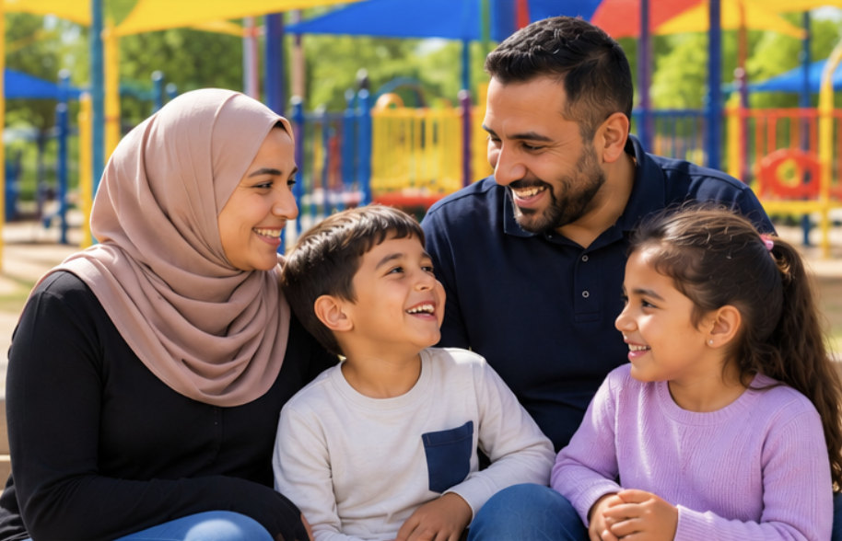 | It also gives special attention to:  - children, young people and families  - people from different cultures  - LGBTIQ+ people

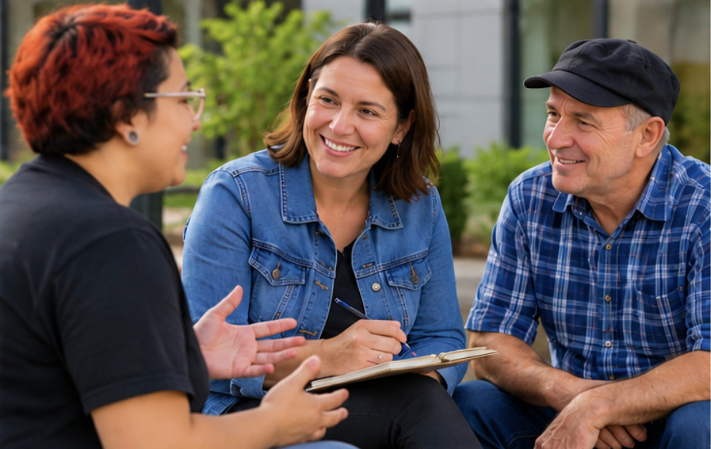 | People outside these groups may also need support to take part.

What people have told us
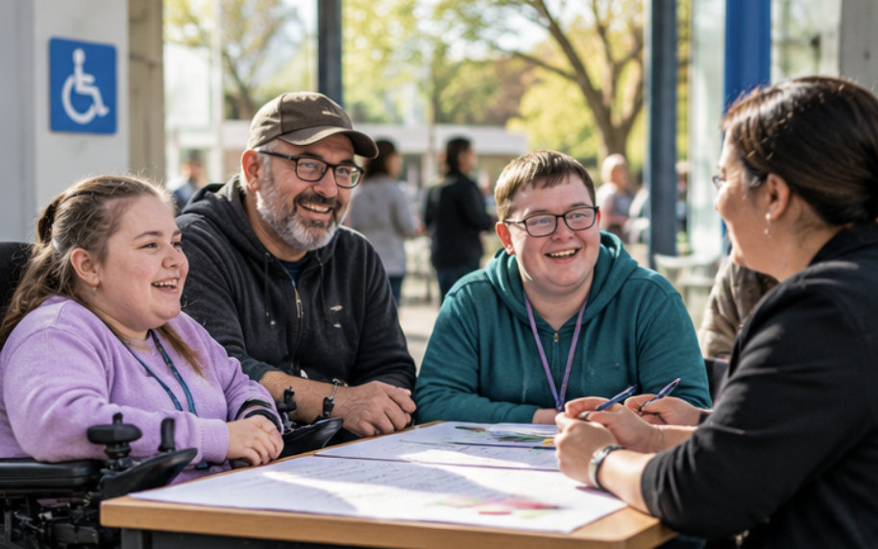 | People with disability have told Council about the importance of access, inclusion and having a say.

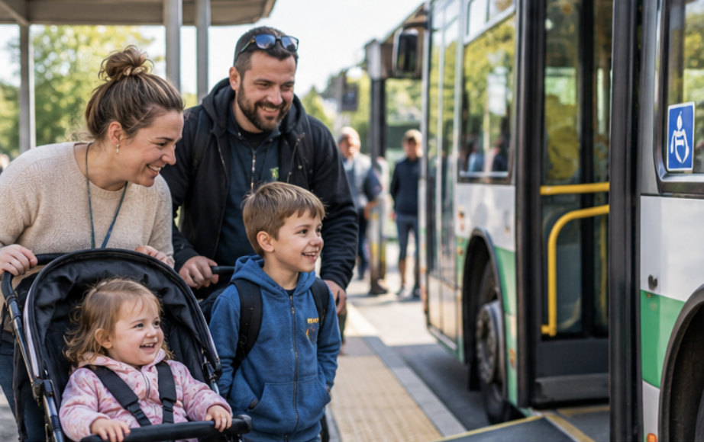 | Families have asked for better access to local services and transport.

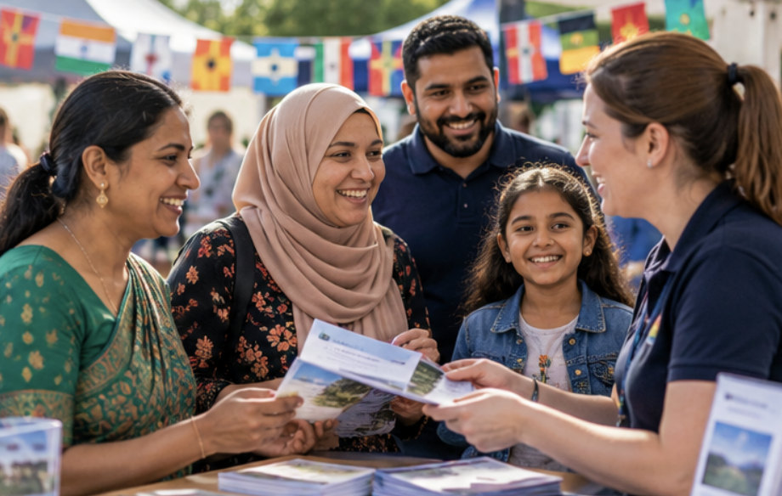 | People from different cultures have asked for more welcoming activities and information in languages they understand.

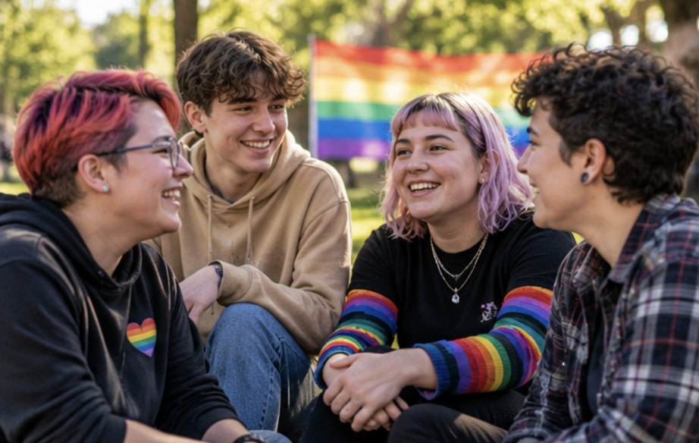 | Some LGBTIQ+ people have asked for welcoming places where they can connect with others.

Our plan has 5 areas of work
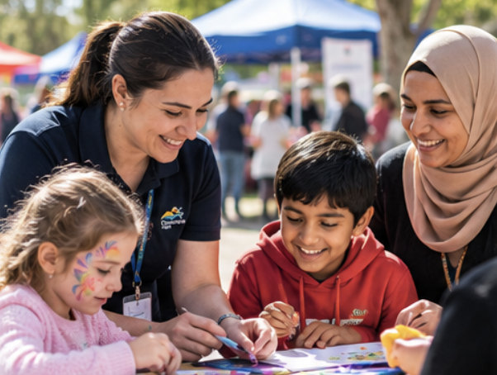 | 1. Council services, programs and events that meet different people’s needs.

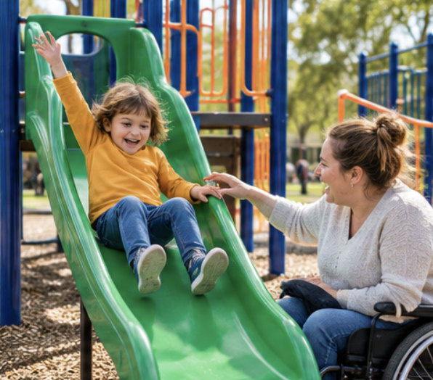 | 2. Safe, connected and accessible places to live, work, learn and play.

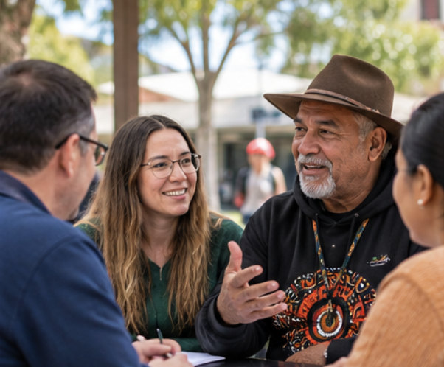 | 3. A community where people can join in, share ideas and help make decisions.

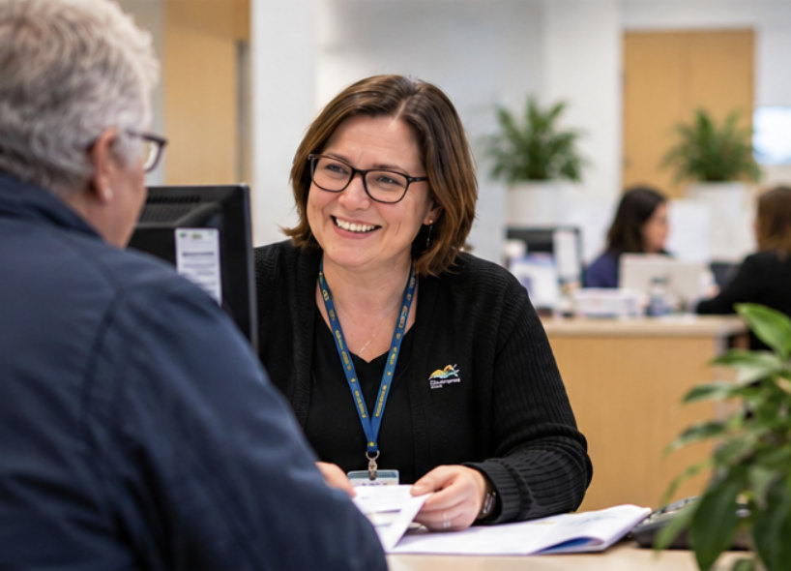 | 4. A fair, safe and welcoming Council workplace.

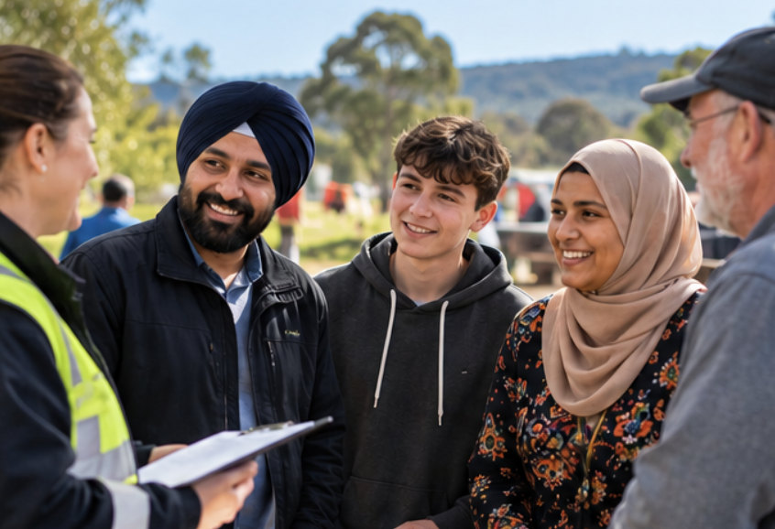 | 5. Council working with others and speaking up for the community.
1. Services and activities for everyone
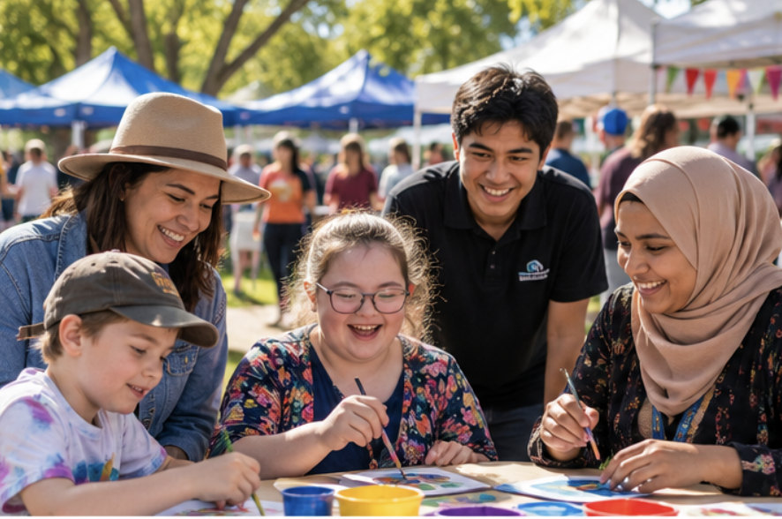 | We will offer and support events and programs that welcome different people.

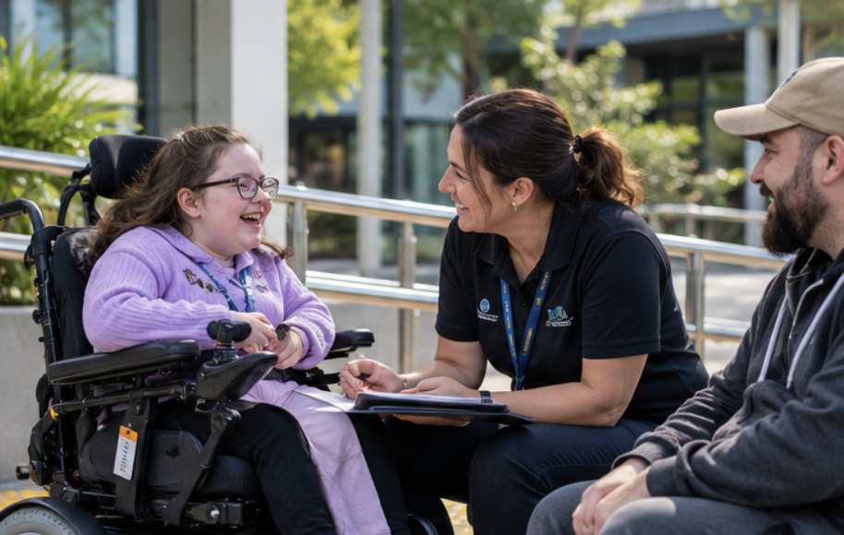 | We will work with people with disability to help make Council services and events easier to use.

 | We will make information easier to read and understand.  This can include accessible formats and help with languages.

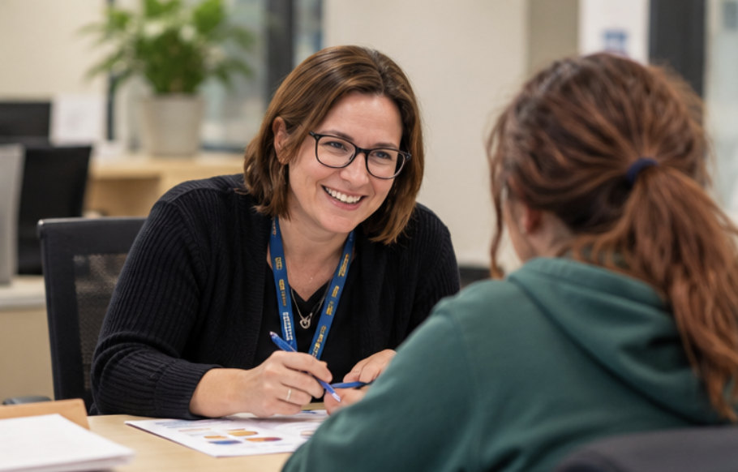 | We will help people find local support.  We will train staff to respond with care to people who have had difficult experiences.

2. Places that work for more people
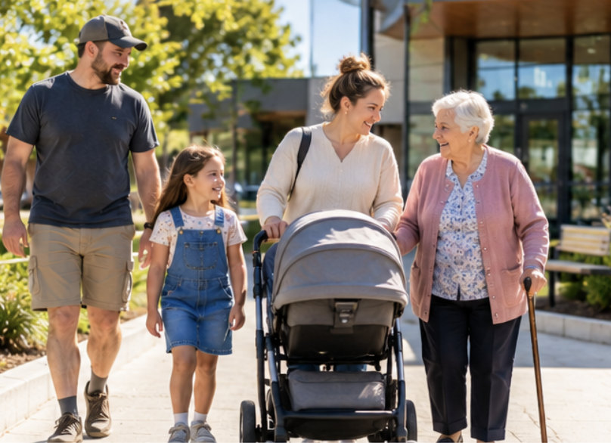 | We will plan Council buildings, parks and other public places with different people’s needs in mind.

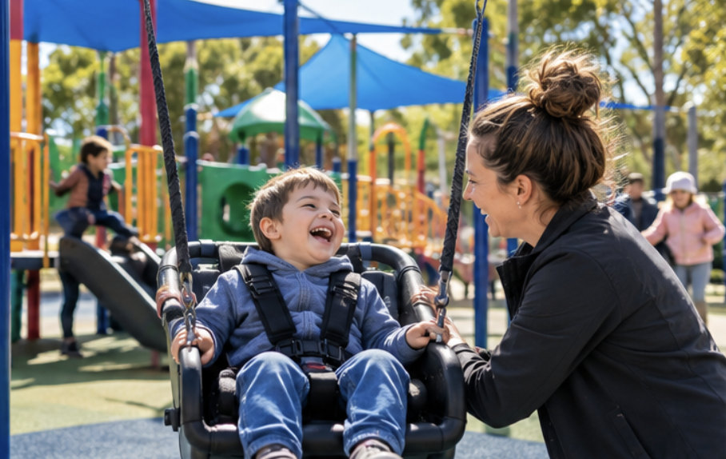 | This includes thinking about access for people with disability when we plan and improve public places.

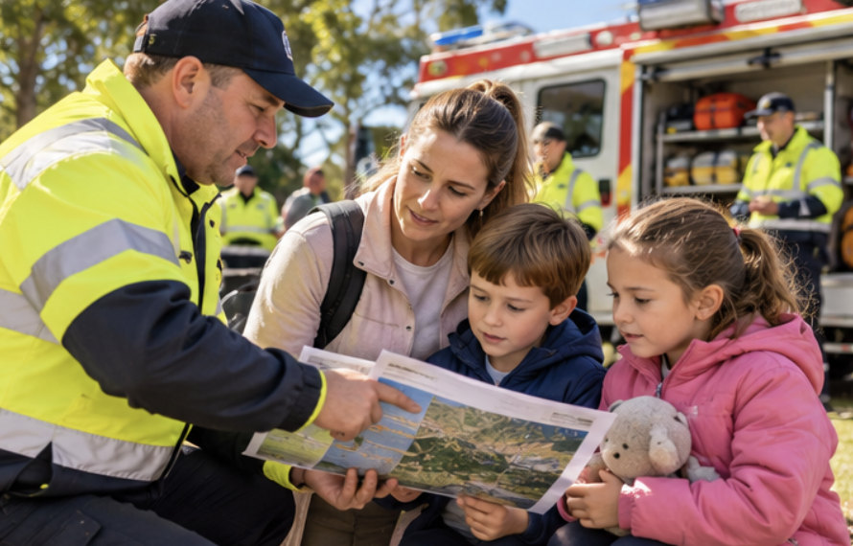 | We will help people feel safer and prepare for emergencies, such as bushfires and floods.

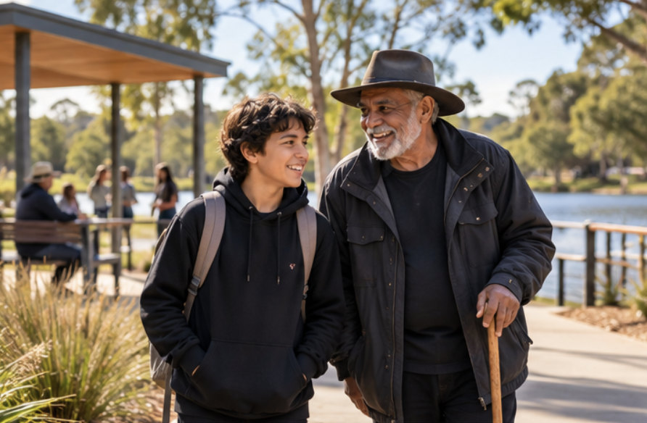 | We will share advice about making community places safe and welcoming.

3. A community where everyone can join in
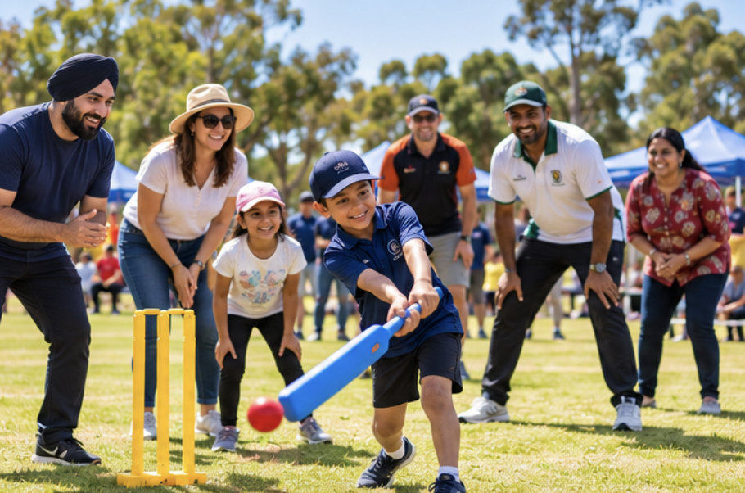 | We will support businesses, sports clubs and community groups to welcome different people.

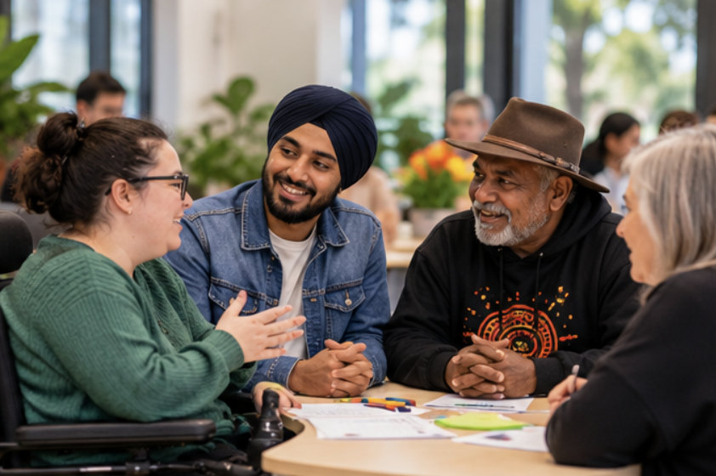 | We will support groups that advise Council, including groups that represent people with disability.

 | We will ask people to help shape Council plans and decisions.

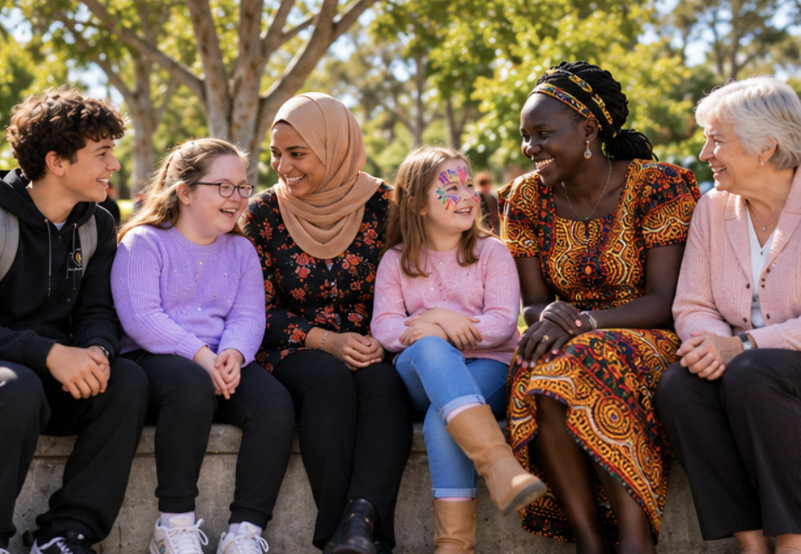 | We will show the many different people in our community in Council pictures and information.

4. A fair and welcoming workplace
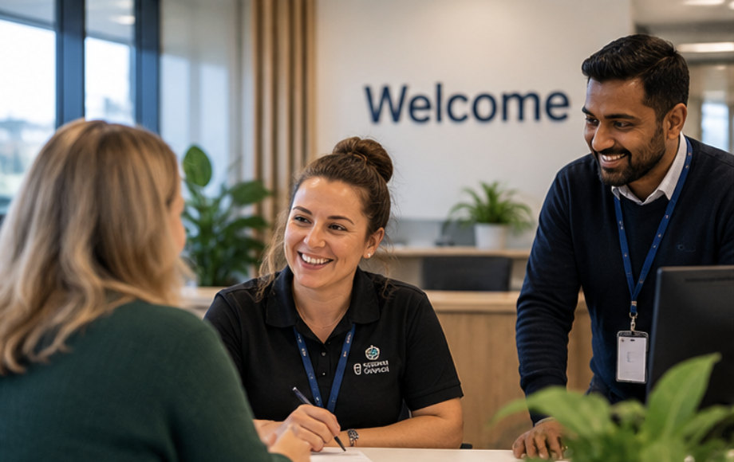 | We want Council to be a safe and welcoming place for staff and volunteers.

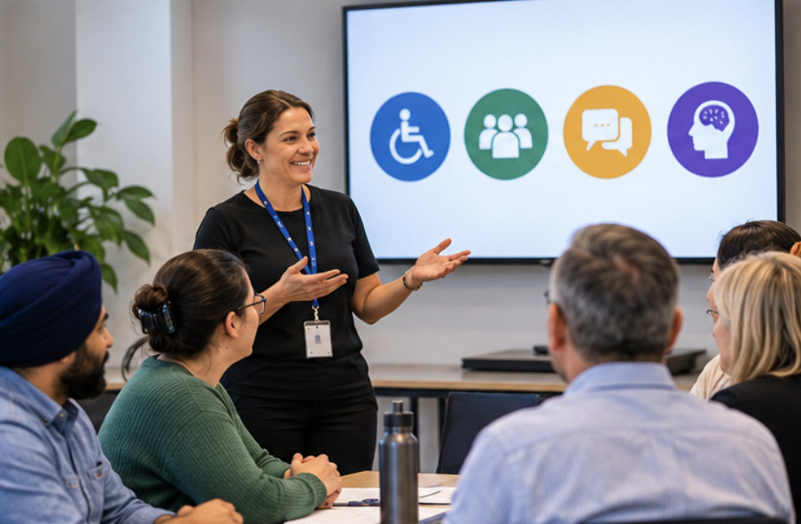 | We will train staff to understand and respond to people’s different needs.

 | We will work to improve job opportunities at Council for people who face unfair barriers, including people with disability.

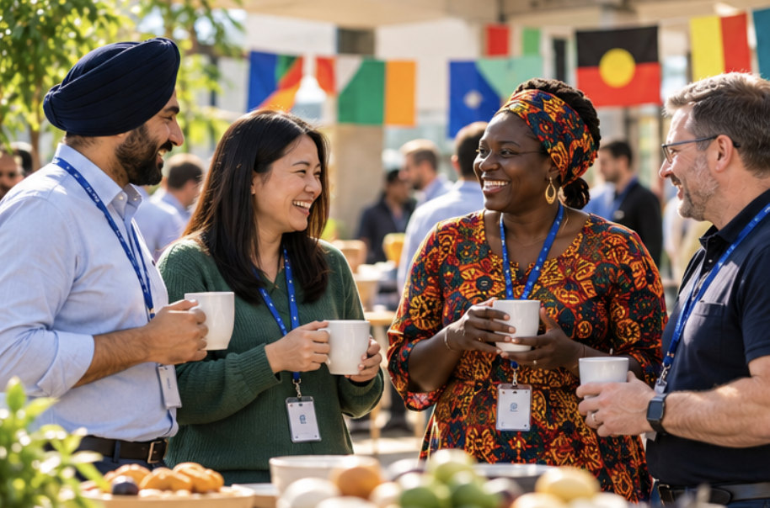 | We will celebrate our different backgrounds and make inclusion part of Council rules and plans.

5. Working together and speaking up
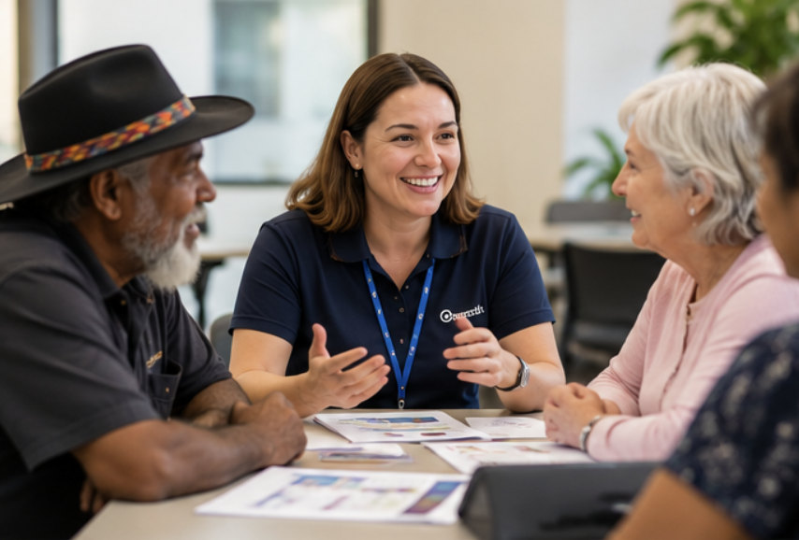 | Council will work with community groups and other organisations to make Cardinia fairer.

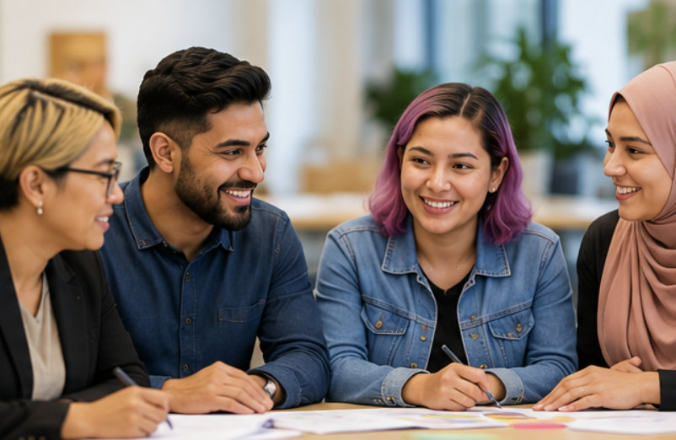 | We will think about how our decisions affect people of different genders and backgrounds.

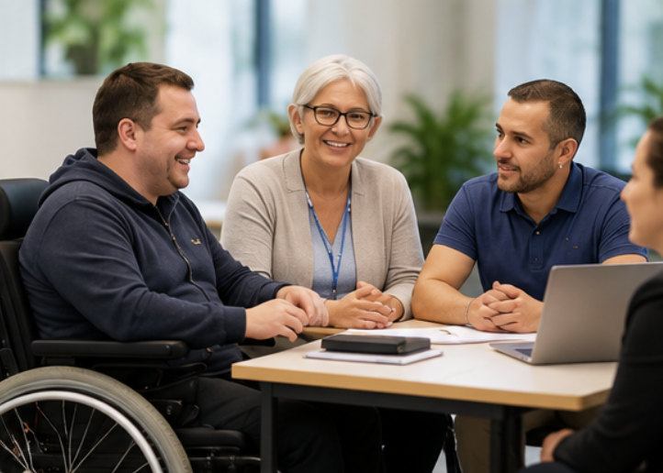 | We will include different community groups, including people with disability, in partnerships and advisory groups.

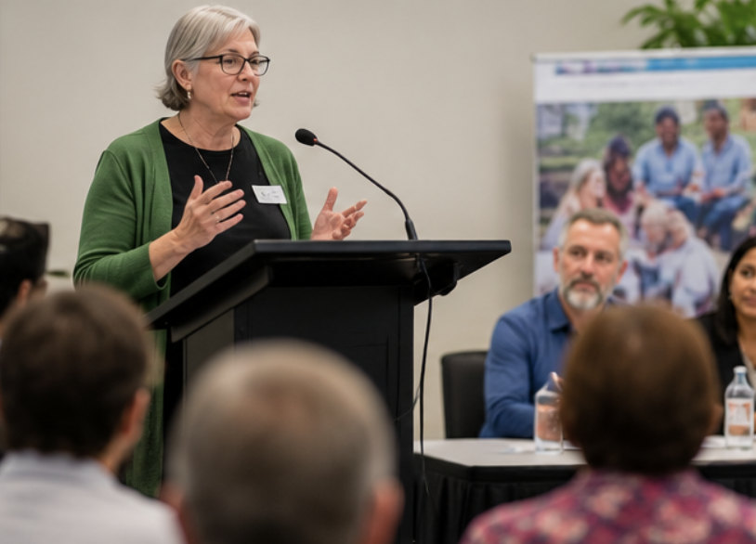 | We will speak up for changes that help people in our community.

How this supports people with disability
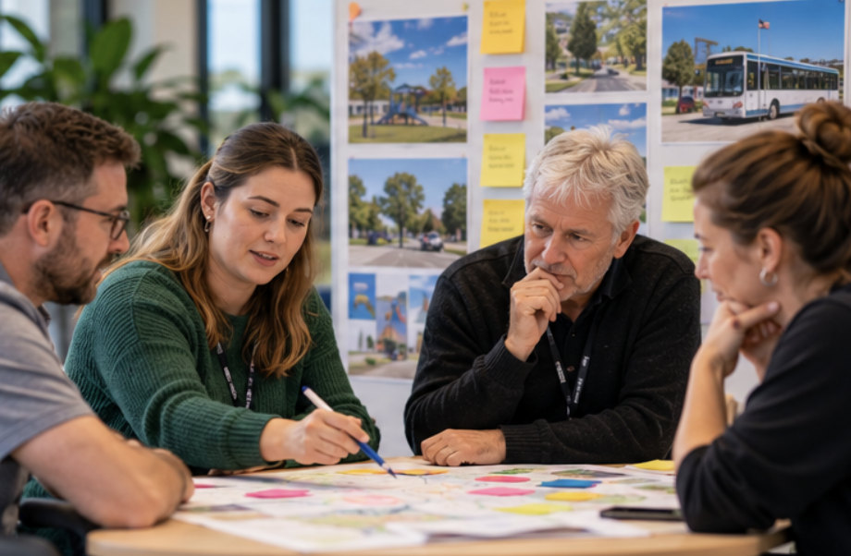 | People with disability should be able to join in community life and help make decisions.

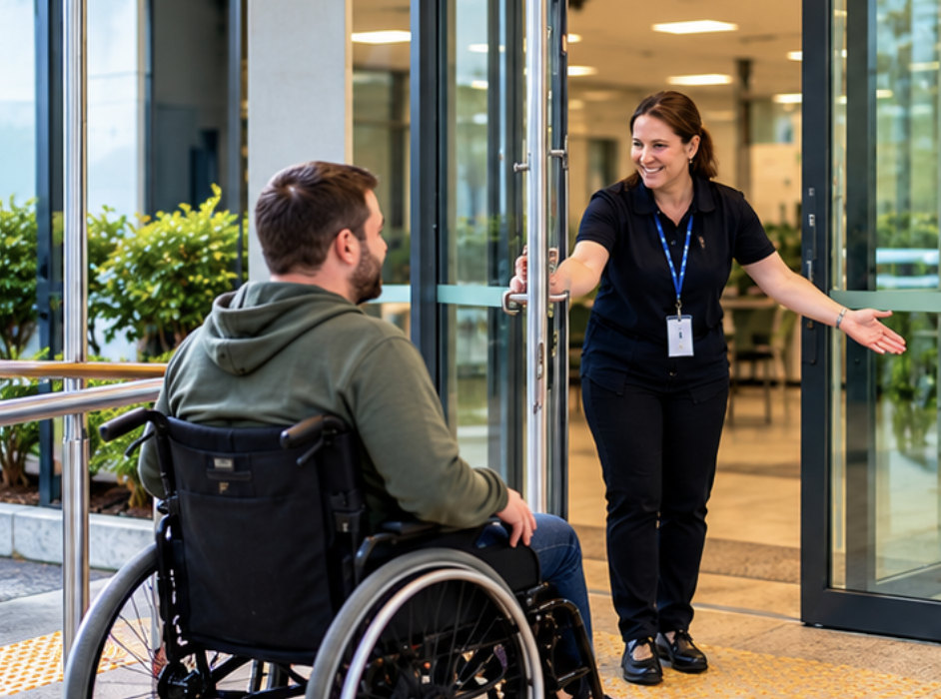 | Council will work to improve access to its places, services, information and events.

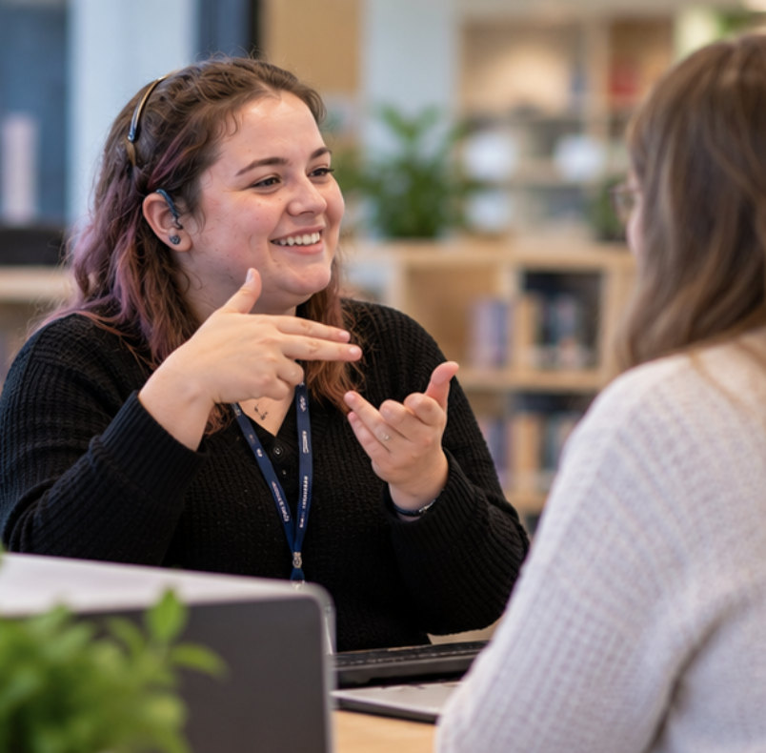 | Council will work to improve job opportunities for people with disability.

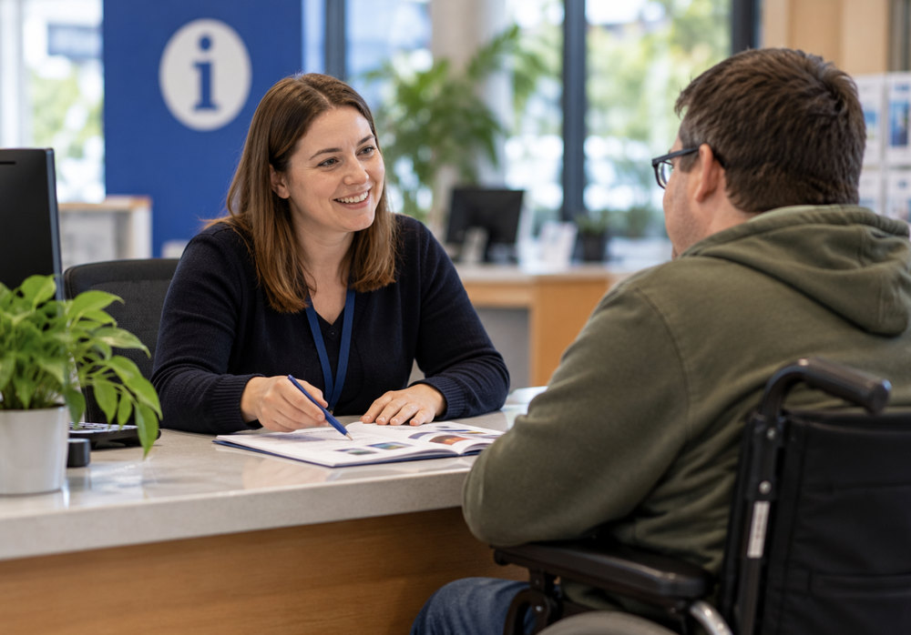 | Council will support fair treatment and better understanding of people with disability.

How we will check our work
 | We will check what we have done and what has improved.

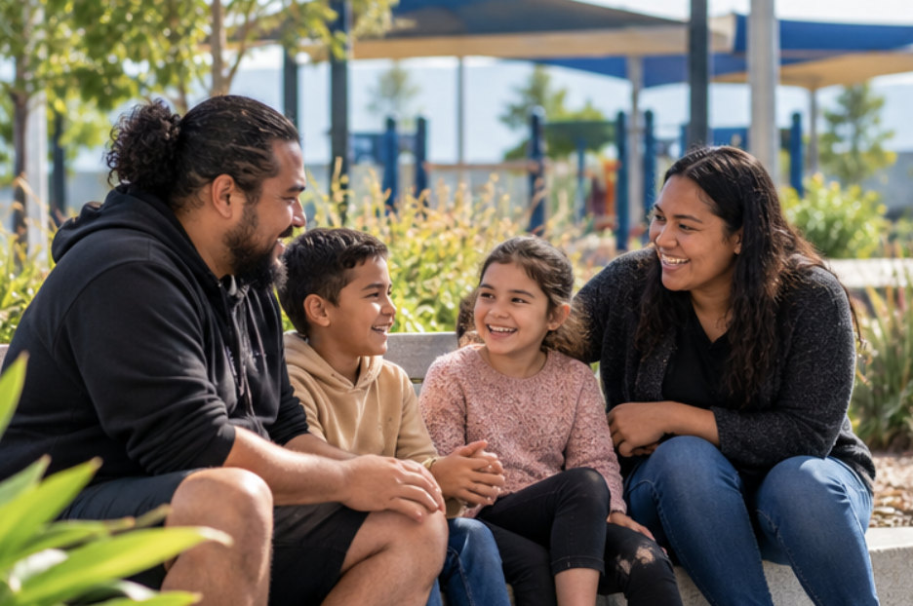 | We will look at how people use Council services and places.

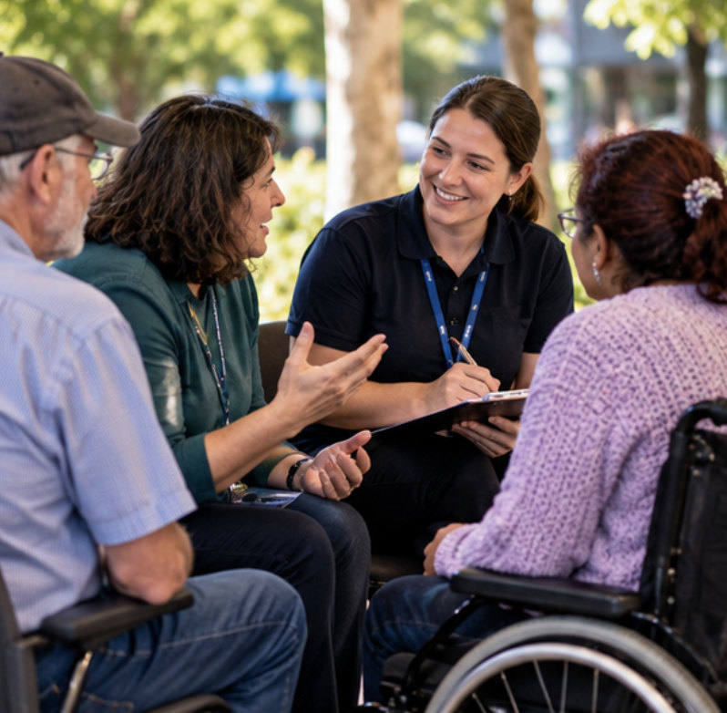 | We will listen to community feedback, including feedback from people with disability.

 | We will report on our progress each year.

Tell us what you think
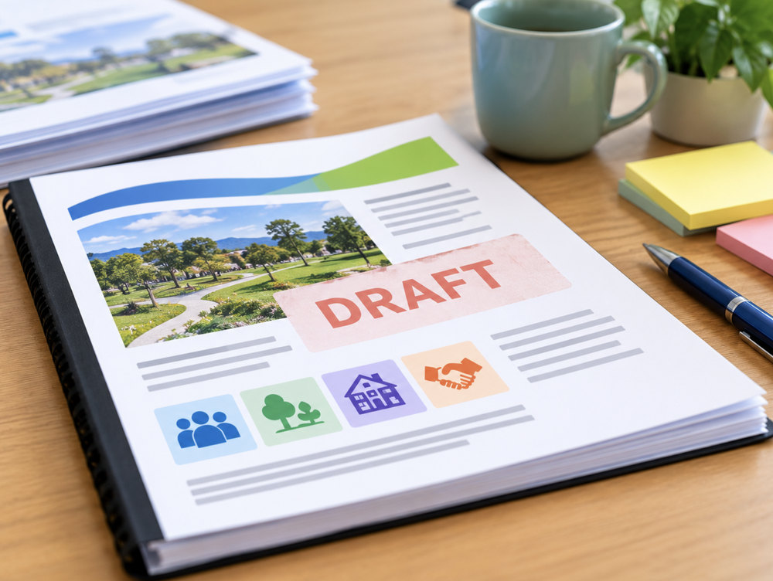 | This is a draft plan.  A draft is a plan that is not finished yet.

 | We want to know what you like, what we should change and what else Council could do.

 | You can ask someone to help you give feedback.

 | Please tell us what you think by 17 November 2026.  Contact Council for ways to give feedback.

What happens next?
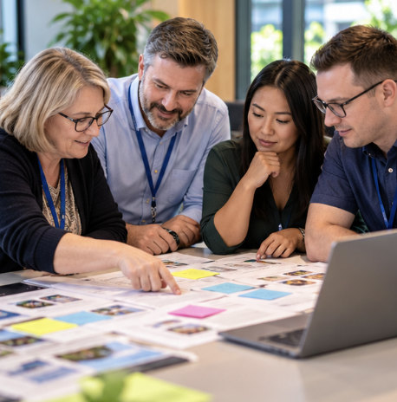 | Council will read and consider the feedback people give us.

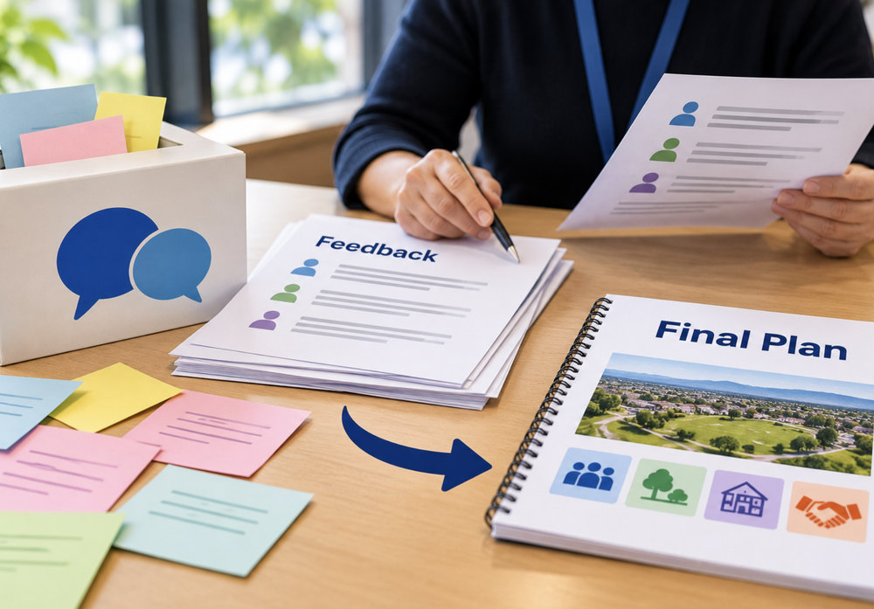 | We will use the feedback when we decide on the final plan.

 | The plan will guide Council work from 2026 to 2030.

Word list
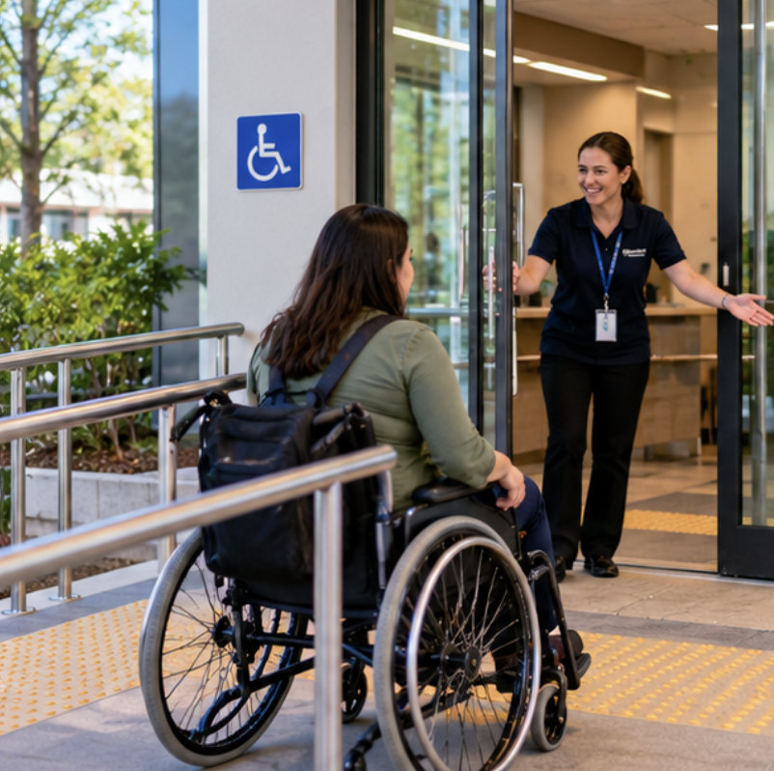 | Accessible  Easy for people to get into, understand or use.

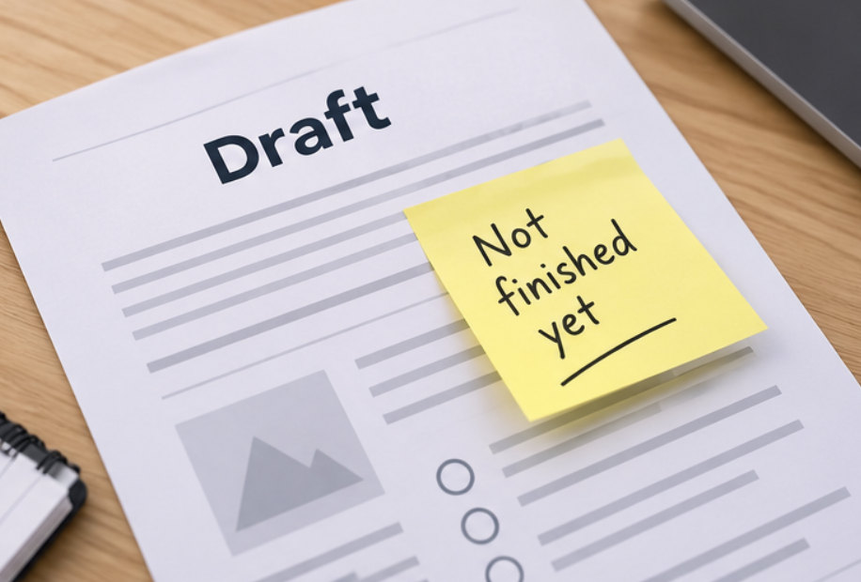 | Draft  A plan that is not finished yet.

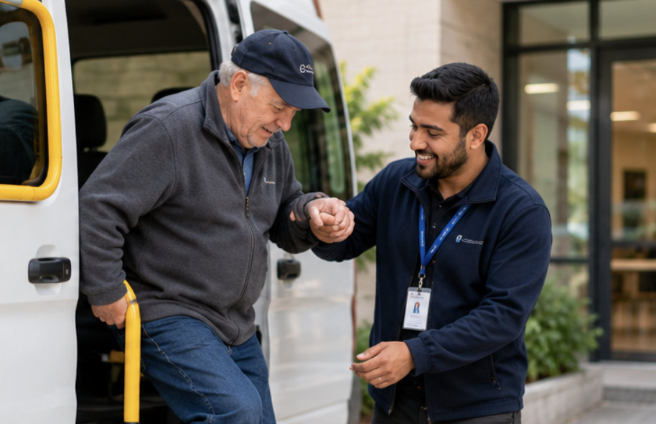 | Equity  Giving people the support they need to have a fair chance.

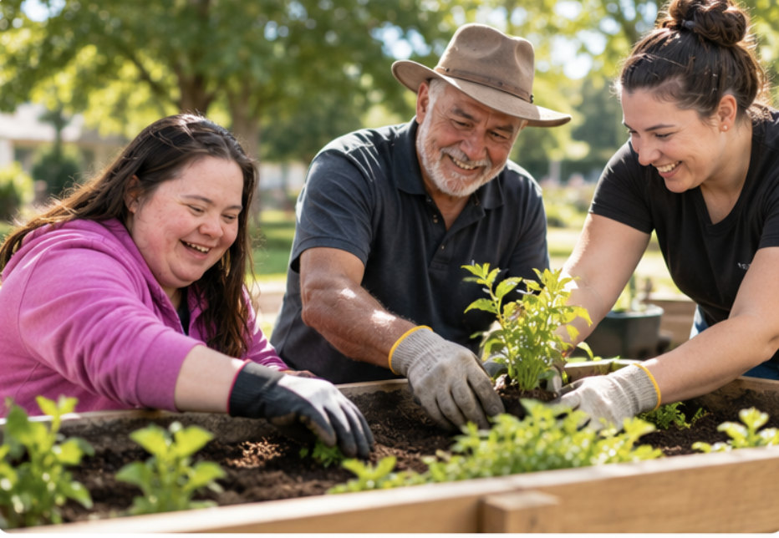 | Inclusion  When people feel welcome and can take part.

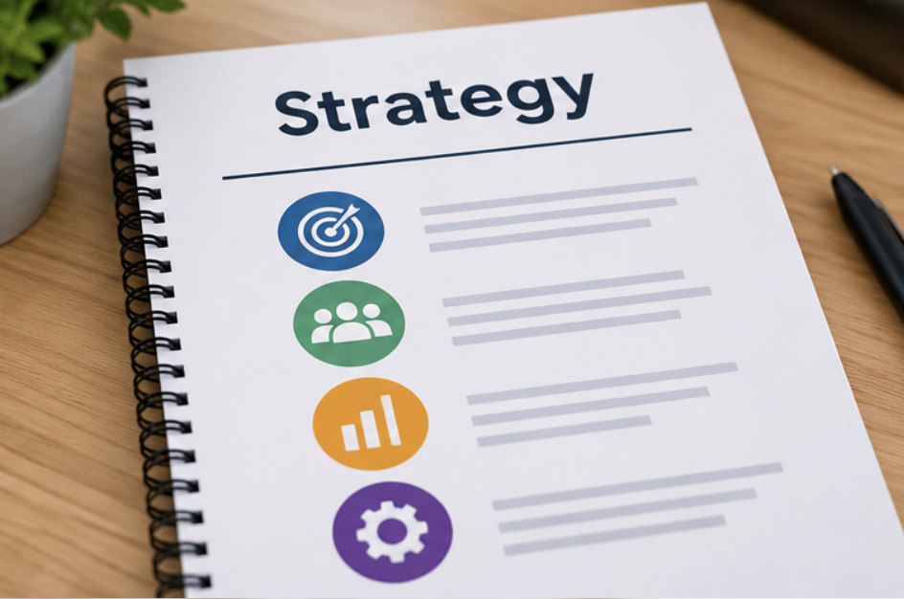 | Strategy  A plan for what Council wants to achieve.
Action Plan
A list of actions that Council will deliver.

Contact Council
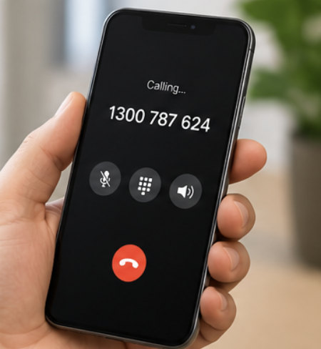 | Phone  1300 787 624

 | Email  mail@cardinia.vic.gov.au

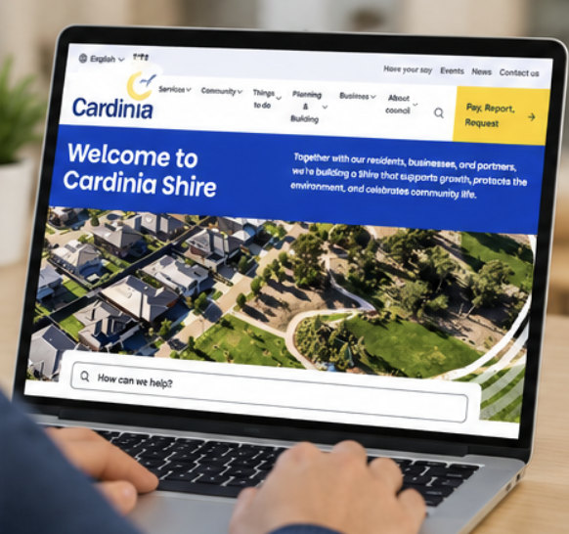 | Website  www.cardinia.vic.gov.au

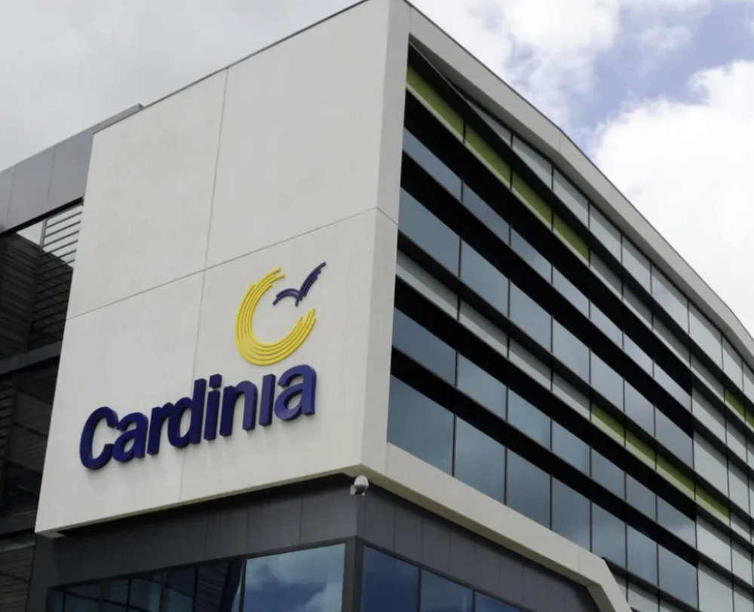 | Civic Centre  20 Siding Avenue  Officer VIC 3809

